**PROJECT DOCUMENATION**

**PROJECT NAME : SMART PARKING SYSTEM**

**Introduction :**

A **Smart Parking System** is an **automated parking management solution** that monitors the availability of parking slots and provides real-time status updates to drivers. The system is designed to **detect vehicles entering and exiting the parking area** and to **keep track of occupied and vacant slots**. By using **infrared (IR) sensors,** the system can efficiently determine whether a parking space is available or occupied. This information is then displayed on an **LCD screen** for easy monitoring.

In many urban areas, parking space congestion is a major challenge, leading to wasted time, increased fuel consumption, and unnecessary stress for drivers. Traditional parking systems rely on **manual monitoring**, which is inefficient and prone to human error. The **Smart Parking System** addresses these challengesby **automating** the process and **minimizing human intervention.**

**Components Required :**

* 1. **Arduino Uno**:
* A microcontroller board used for controlling sensors, motors, and displays in various projects.
  1. **Breadboard**
* A tool for prototyping circuits without soldering, allowing easy component connections.
  1. **IR Sensors**
* Infrared sensors used for object detection, proximity sensing, or motion tracking.
  1. **Servomotor**
* A motor that rotates to a precise angle based on PWM signals, commonly used for controlled movements.
  1. **LCD (Liquid Crystal Display)**
* A screen used to display text, numbers, or symbols in embedded systems.
  1. **I2C Module**

1. An interface that simplifies LCD communication with microcontrollers, reducing the number of required pins.
2. **Connecting wires**

* Used to establish electrical connections between different components in the circuit.

**Working Principle :**

* 1. **Vehicle Detection**
* IR Sensors detect the presence of a vehicle in a parking slot.
* If a vehicle is present, the sensor sends a signal to the Arduino Uno.
  1. **Data Processing & Display**
* The Arduino Uno processes the sensor data and updates the parking status.
* The availability of parking slots is displayed on the LCD with I2C module for easy visibility.
  1. **Barrier Control**
* A servomotor can be used to operate an automated parking barrier.
* When a vehicle is detected at the entrance, the Arduino controls the servo to open or close the barrier.
  1. **System Integration & Power**
* The components are connected via a breadboard for circuit integration.
* A power supply cable provides the necessary voltage to run the system.

**Program :**

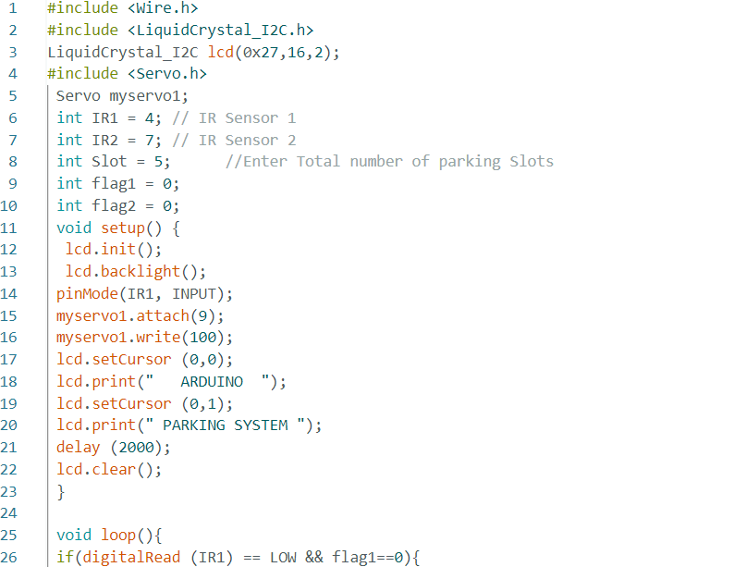

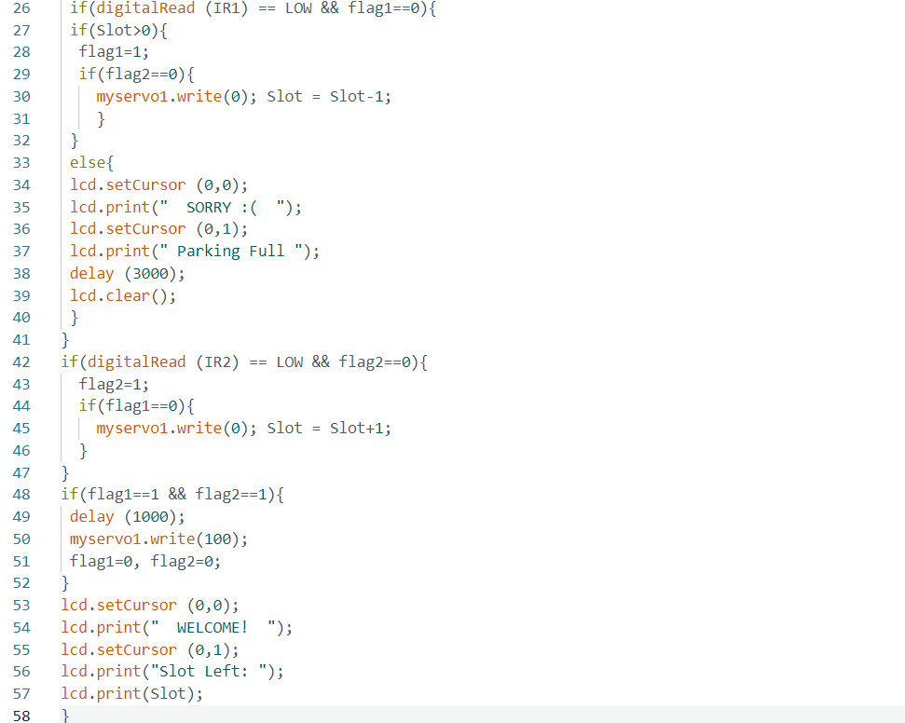

**Image :**

